Regression Analysis: y1 versus x2; x3

Analysis of Variance

Source DF Adj SS Adj MS F-Value P-Value
Regression 2 132,32 66,16 6,51 0,014
x2 1 77,37 77,37 7,61 0,019
x3 1 54,95 54,95 5,40 0,040
Error 11 111,85 10,17
Total 13 244,17

Model Summary

S R-sq R-sq(adj) R-sq(pred)
3,18875 54,19% 45,86% 16,20%

Coefficients

Term Coef SE Coef T-Value P-Value VIF
Constant 3,102 0,852 3,64 0,004
x2 2,78 1,01 2,76 0,019 1,00
x3 -2,34 1,01 -2,32 0,040 1,00

Regression Equation

y1 = 3,102 + 2,78 x2 - 2,34 x3

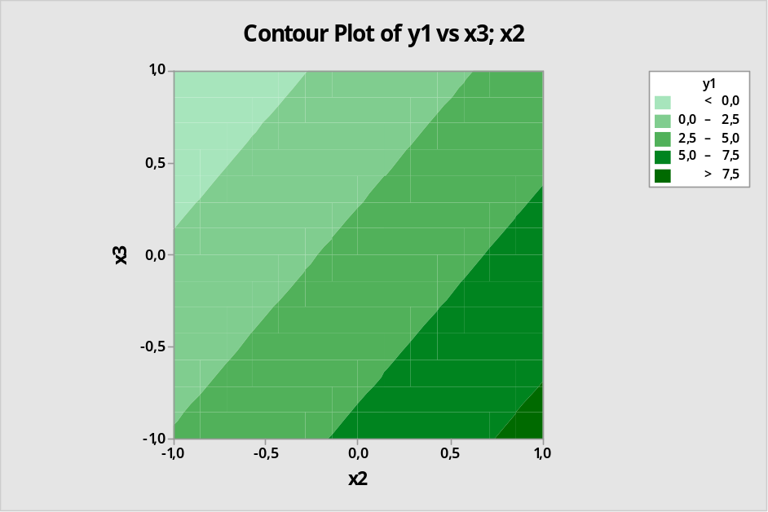

Regression Analysis: y2 versus x1; x2; x3

Analysis of Variance

Source DF Adj SS Adj MS F-Value P-Value
Regression 5 93,995 18,799 12,58 0,001
x1 1 17,043 17,043 11,41 0,010
x2 1 36,703 36,703 24,57 0,001
x3 1 23,648 23,648 15,83 0,004
x1*x2 1 8,522 8,522 5,70 0,044
x2*x3 1 8,078 8,078 5,41 0,049
Error 8 11,953 1,494
Total 13 105,948

Model Summary

S R-sq R-sq(adj) R-sq(pred)
1,22234 88,72% 81,67% 37,31%

Coefficients

Term Coef SE Coef T-Value P-Value VIF
Constant 2,372 0,327 7,26 0,000
x1 -1,305 0,387 -3,38 0,010 1,00
x2 1,916 0,387 4,96 0,001 1,00
x3 -1,538 0,387 -3,98 0,004 1,00
x1*x2 -1,032 0,432 -2,39 0,044 1,00
x2*x3 -1,005 0,432 -2,33 0,049 1,00

Regression Equation

y2 = 2,372 - 1,305 x1 + 1,916 x2 - 1,538 x3 - 1,032 x1*x2 - 1,005 x2*x3

